DEP Task 4: Crafting Social Media Posts

In this task, I mentioned a fictional e-commerce business website. It includes 3 Social Media posts.

# Company Name: **PetPals**

**1**

**Introducing new product**

## **Caption**

🌍 **Playtime just got greener!** Check out our new eco-friendly pet toys made from 100% recycled materials. Perfect for your furry friend and the planet! 🌱 #EcoFriendlyPets

#SustainableLiving

## **Copy**

Hey, pet lovers! We’re thrilled to introduce our Eco-Friendly Pet Toys, where playtime meets planet-saving! 🎉

These toys are designed with your furry friends in mind, and they’re packed with benefits that both pets and the Earth will love!

Why You’ll Adore Our Eco-Friendly Pet Toys:

* Made from high-quality recycled materials
* We use only non-toxic materials
* Every time you choose our eco-friendly toys, you’re helping reduce waste and promote a healthier planet.

It’s a win-win for everyone!

We can’t wait to see your adorable pets having a blast with their new toys! Snap a pic of your furry friend in action and tag us for a chance to be featured in our stories! 📸🐶🐱



**2**

**Promotional post**

## **Caption**

🚨 **Limited-Time Offer!** Get 20% off all grooming services this month only. Book your spot now and let us pamper your pet! 🐾 Use code **GROOM20** at checkout. #PetPalsDeals

#PetCareSavings

## **Copy**

Attention, pet parents! 🎉 We’re excited to announce a Limited-Time Offer that you won’t want to miss! For this month only, enjoy 20% off all grooming services at PetPals!

**Why Grooming is Essential for Your Pet:**

* Regular grooming helps maintain your pet’s coat, skin, and overall health.
* Our professional groomers provide a calming experience, making bath time and grooming enjoyable for your furry friend.
* Your pet will leave looking and smelling amazing!

Hurry! This offer is only available for a limited time, and spots are filling up fast! Don’t wait—give your pet the pampering they deserve while saving some cash!

Book your appointment today by visiting our website. Use promo code **GROOM20** to avail the offer!!! 🐶✨

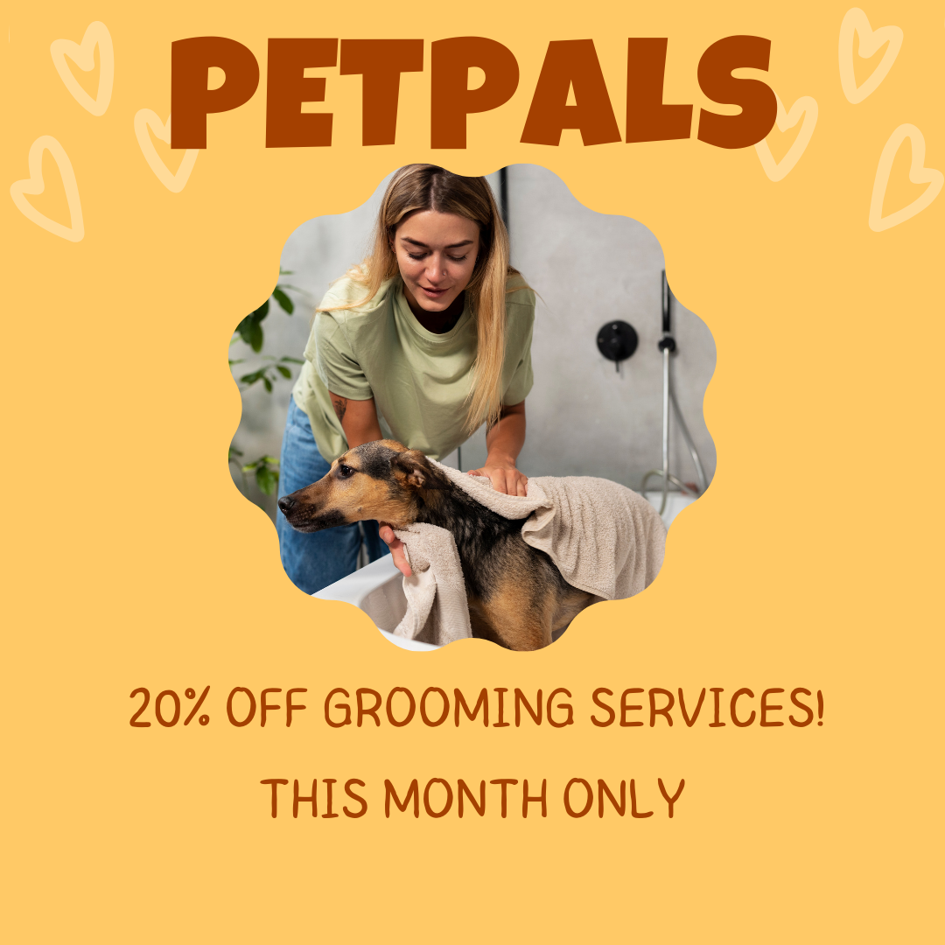

**3**

**Customer Contest post**

## **Caption**

🎉 It's time for the **#PetPalsChallenge!** Show us your pet's best trick or funniest moment and stand a chance to win a PetPals Subscription Box! 📦

Tag us and use the hashtag to enter. We can't wait to see your furry friends in action! 🐕🐈

#PetPalsChallenge

## **Copy**

Calling all pet parents! 🐾 Are you ready for the most exciting challenge ever? It's time to show off your furry friend's amazing talents in the #PetPalsChallenge!

We want to see your pets, whether they're performing mind-blowing tricks or having a giggle-worthy moment that makes you crack up!

This is your chance to showcase your pet's unique personality and win some awesome prizes!

**Challenge Rules (super easy!)**

1. Get a video or photo of your pet doing their best trick or being their funniest self.
2. Post your entry on social media, tag @PetPals, and use the hashtag #PetPalsChallenge to enter.
3. You have until 30th september to submit your entry. Don't delay—get snapping!

**Prizes (you're gonna love these!)**

* Grand Prize: A fabulous PetPals Subscription Box filled with the most amazing treats and toys for your pet!
* Runner-Up Prizes: Special shoutouts on our social media and a chance to be featured in our community highlights.

The PetPals community is all about celebrating the joy and laughter our pets bring into our lives. So, what are you waiting for? Grab your camera and let's show the world what makes your furry friend so special! 🐶🐱

We can't wait to see all the amazing entries! Let the challenge begin! 🎉✨

